1. Laporan User

Windows Print

PDF

Excel

1. Laporan Buku

Windows Print

PDF

Excel

1. Laporan Peminjaman

Windows Print



PDF

Excel

1. Laporan Pengembalian

Windows Print

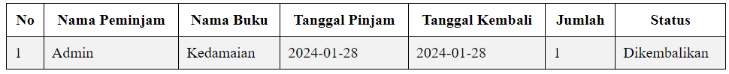

PDF

Excel

1. Laporan Koleksi

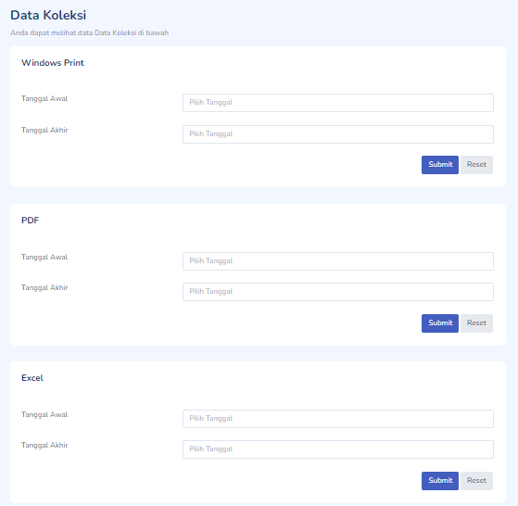

Windows Print



PDF

Excel

1. Laporan Comment

Windows Print

PDF

Excel

